How to test the API

Download Postman: <https://www.postman.com/downloads/>

Put the API files into a project directory, for example:

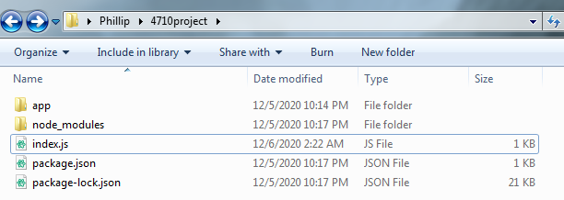

Open the app directory, then open the config directory.

Open the db.config.js file.

It should currently say:

**module.exports = {**

**HOST: "localhost",**

**USER: "root",**

**PASSWORD: "root",**

**DB: "4710project"**

**};**

You will need to edit the above to match your mysql db credentials.

Navigate to the project directory in command line, then use either:

node index.js OR nodemon index.js to start the API server

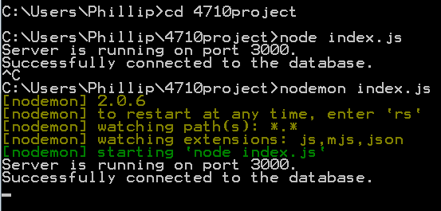

**NOTE:** To turn off the api server, press: ctrl + c

Open postman and create a new collection:

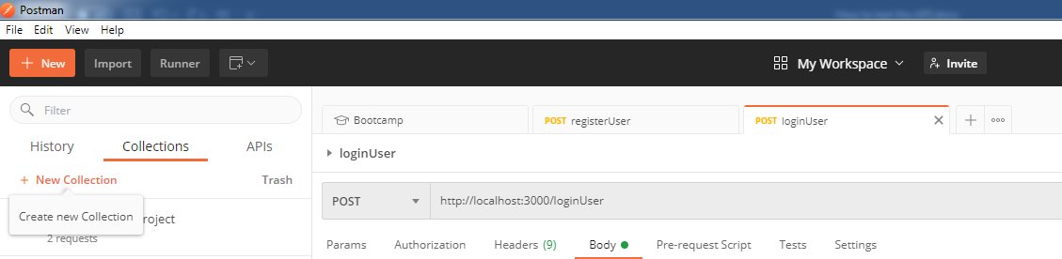

create request using the + icon in the top middle:

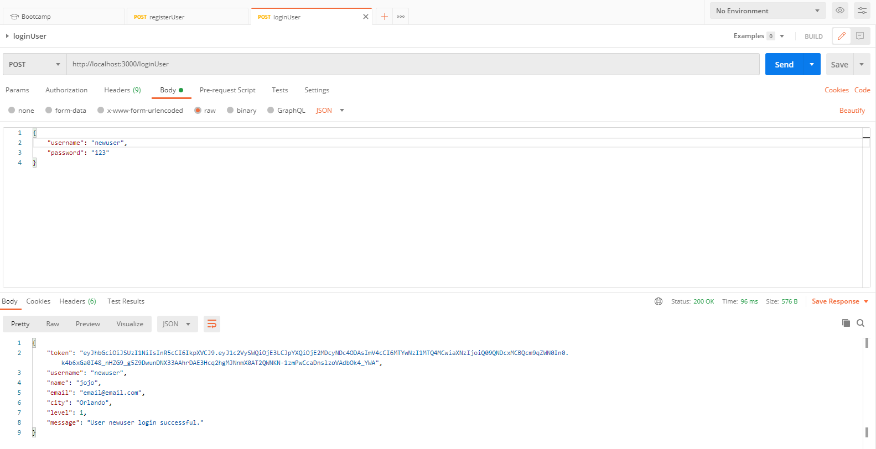

Set up the request according to the api call

For example, to test registerUser

Make sure it is a POST request, enter: <http://localhost:3000/loginUser>

Click on “Body”, raw, make sure it is in JSON format and enter data in the JSON format

some examples:

**{**

**“username”: “Abocreature”,**

**“password”: “pass”**

**}**

or

**{**

**“username”: “Abocreature”,**

**“password”: “pass”,**

**“name”: “Zack”,**

**“city”: “Orlando”**

**}**

Press send when you’re done setting up the request.

You should get a JSON package back with username and message.

I also recommend making the username for users table unique, so that you can’t accidentally create more than one user with the same username.

**NOTE:** the password is hashed before it is stored in the database, so if you entered the username and password into the database manually, then try to use the loginUser call, it will say wrong password. You need to use registerUser to insert a user first.